Practical No 10 Web Browser Forensics

* Web Browser working
* Forensics activities on browser
* Cache / Cookies analysis

Last Internet activity

Click on start 🡪 BrowserHistoryExaminer 🡪 It will show following window

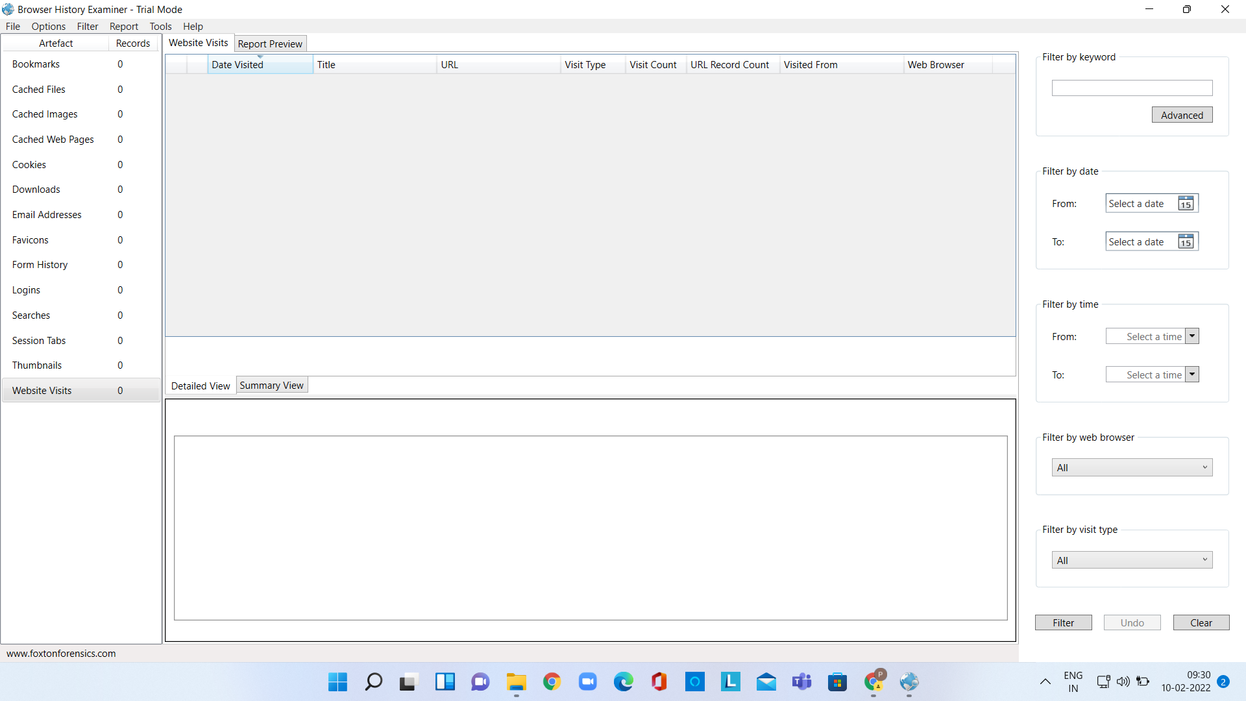

Click on File 🡪 Capture History

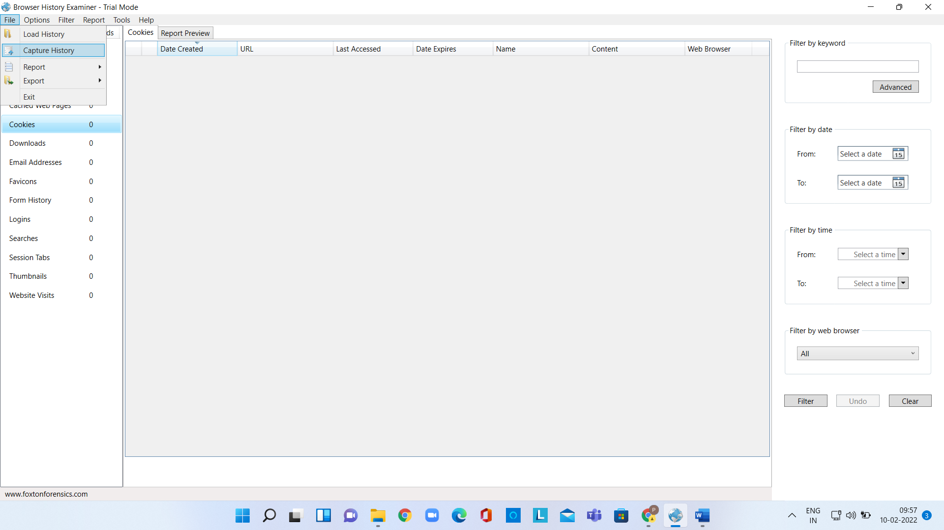

It will show following window

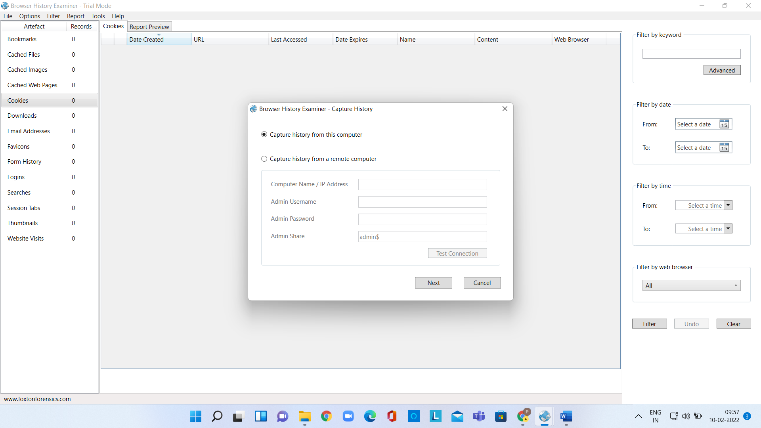

Choose History from Computer and Click on Next. *T will show following tab*

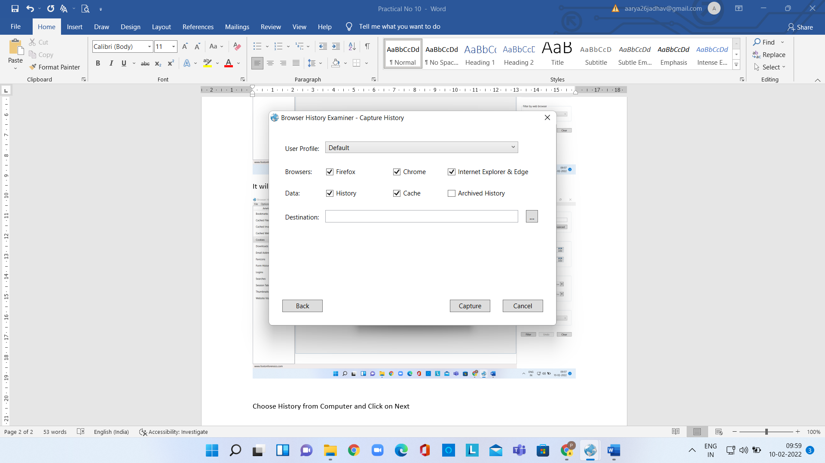

*Then click on Capture. It will show first 25 activities*

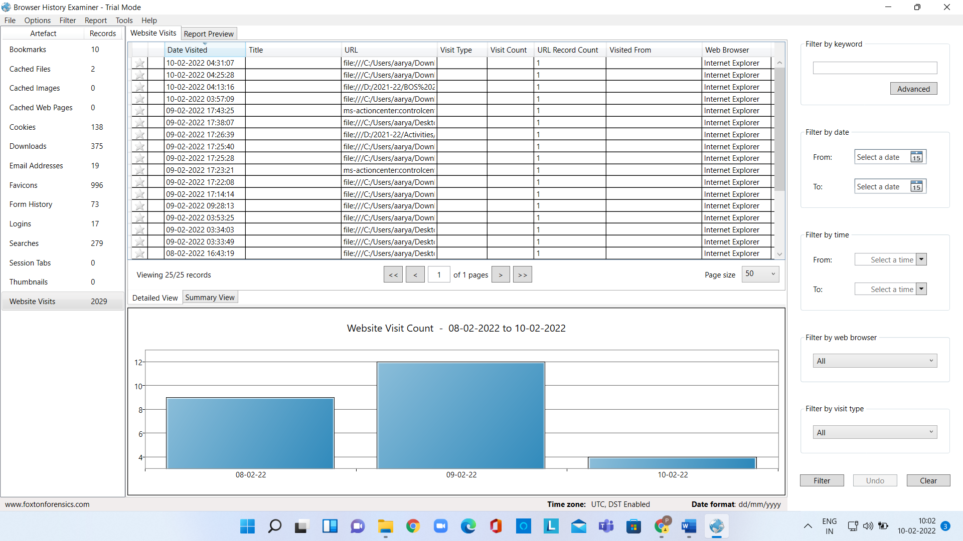

Then one by one you can see

* Forensics activities on browser
* Cache / Cookies analysis

And also you can save this information in form of report